2.1 INTRODUCTION
Transformer is considered to be a backbone of a power system. One of the main reasons of adopting alternate current (AC) system instead of direct current (DC) system for generation, transmission, and distribution of electric power is that the alternating voltage can be increased or decreased conveniently by means of a transformer. In fact, for economical reasons, electric power is required to be transmitted at high voltages, whereas it has to be utilized at low voltages from safety point of view. This increase in voltage for transmission and decrease in voltage for utilization can only be achieved by using a transformer. Hence, it is described that transformer is backbone of a power system. In this chapter, we shall discuss the general features and principle of operation of single-phase transformers.

TRANSFORMER
A transformer is a static device that transfers AC electrical power from one circuit to the other at the same frequency, but the voltage level is usually changed.
The block diagram of a transformer is shown in Figure 10.1. When the voltage is raised on the output side (V₂ > V₁), the transformer is known as step-up transformer, whereas the transformer in which the voltage is lowered on the output side (V₂ < V₁) is called a step-down transformer.
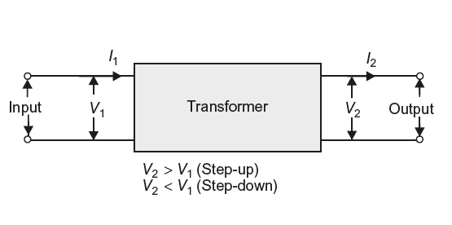
Fig. 1 Block diagram of a transformer

2.2Construction of transformer:
In our country, usually electrical power is generated at 11 kV. For economical reasons, AC power is transmitted at very high voltages (220 kV or 400 kV) over long distances; therefore, a step-up transformer is applied at the generating station. Then, to feed different areas, voltages are stepped down to different levels (for economical reasons) by transformer at various substations. Ultimately, for the utilization of electrical power, the voltage is stepped down to 400/230 V for safety reasons.
Thus, transformer plays an important role in the power system. The pictorial view of a power transformer is shown in Figure 2. The important accessories are labelled on it.
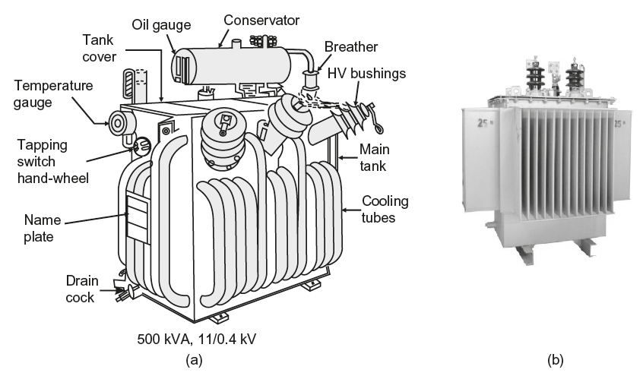
Fig. 2 (a) Oil-immersed air natural cooled transformer (b) Single-phase transformer

The transformer is probably one of the most useful electrical devices ever invented. It can raise or lower the voltage or current in an ac circuit, it can isolate circuits from each other, and it can increase or decrease the apparent value of a capacitor, an inductor, or a resistor. Furthermore, the transformer enables us to transmit electrical energy over great distances and to distribute it safely in factories and homes.

A transformer is a pair of coils coupled magnetically (Fig.3.1), so that some of the magnetic flux produced by the current in the first coil links the turns of the second, and vice versa. The coupling can be improved by winding the coils on a common magnetic core (Fig.3.2), and the coils are then known as the windings of the transformer.

Practical transformers are not usually made with the windings widely separated as shown in Fig.3.1, because the coupling is not very good. Exceptionally, some small power transformers, such as domestic bell transformers, are sometimes made this way; the physical separation allows the coils to be well insulated for safety reasons. Fig.3.2 shows the shell type of construction which is widely used for single-phase transformers. The windings are placed on the center limb either side-by-side or one over the other, and the magnetic circuit is completed by the two outer limbs.
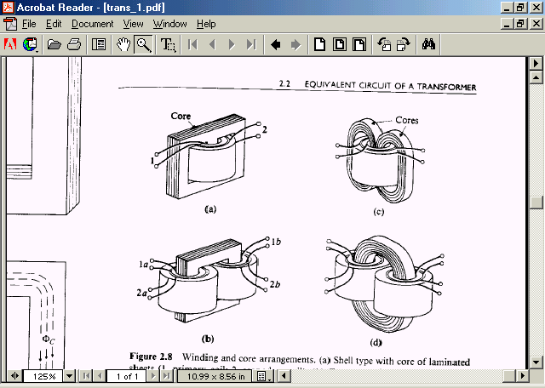
Fig.3.1 Core Type Transformer.
Fig.3.2 Shell Type Transformer.
Two types of core constructions are normally used, as shown in Fig.3.1. In the core type the windings are wound around two legs of a magnetic core of rectangular shape. In the shell type (Fig.3.2), the windings are wound around the center leg of a three legged magnetic core. To reduce core losses, the magnetic core is formed of a stack of thin laminations. Silicon-steel laminations of 0.014 inch thickness are commonly used for transformers operating at frequencies below a few hundred cycles. L-shaped laminations are used for core-type construction and E-shaped laminations are used for shell-type construction. To avoid a continuous air gap (which would require a large exciting current),
For small transformers used in communication circuits at high frequencies (kilocycles to megacycles) and low power levels, compressed powdered ferromagnetic alloys, known as permalloy, are used.
A schematic representation of a two-winding transformer is shown in Fig.3.3. The two vertical bars are used to signify tight magnetic coupling between the windings. One winding is connected to an AC supply and is referred to as the primary winding. The other winding is connected to an electrical load and is referred to as the secondary winding. The winding with the higher number of turns will have a high voltage and is called the high-voltage (HV) or high-tension (HT) winding. The winding with the lower number of turns is called the low-voltage (LV) or low-tension (LT) winding. To achieve tighter magnetic coupling between the windings, they may be formed of coils placed one on top of another (Fig.3.2).
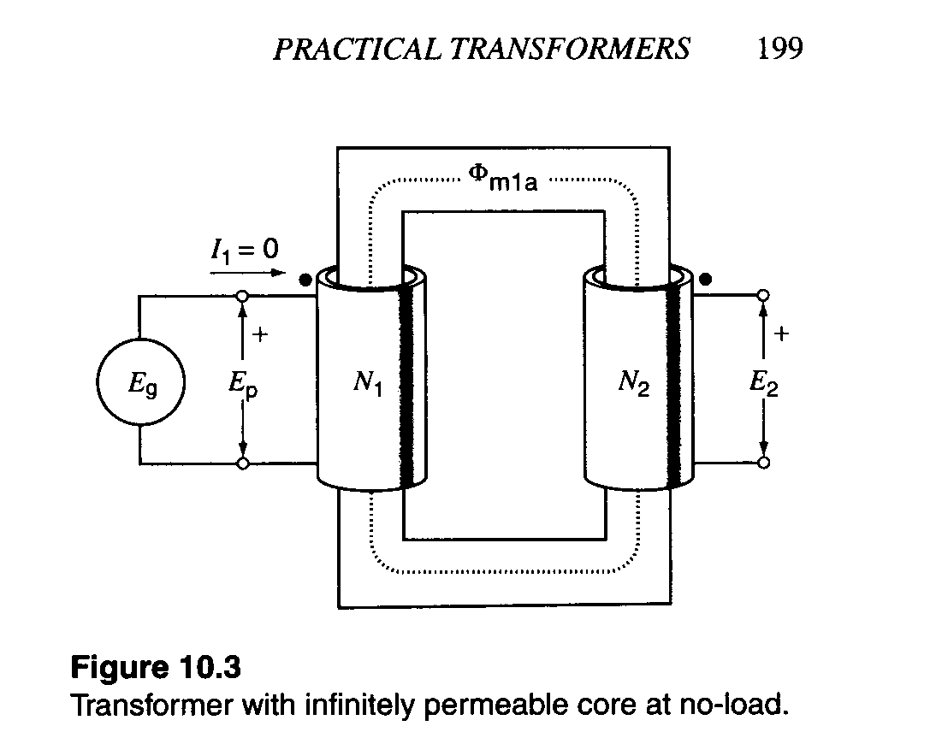
Fig.3.3 A schematic representation of a two-winding transformer

Applications
Main applications of the transformers are given below:
- Used to change the level of voltage and current in electric power systems.
- As impedance-matching device for maximum power transfer in low-power electronic and control circuits.
- As a coupling device in electronic circuits.
- To isolate one circuit from another, since primary and secondary are not electrically connected.
- To measure voltage and currents, these are known as instrument transformers.
Transformers are extensively used in AC power systems because of the following reasons:
- Electric energy can be generated at the most economic level (11 kV−33 kV)
- Stepping up the generated voltage to high voltage, extra high voltage (EHV) (voltage above 230 kV), or to even ultrahigh voltage (UHV) (750 kV and above) to suit the power transmission requirement in order to minimize losses and increase transmission capacity of lines.
- The transmission voltage is stepped down in many stages for distribution and utilization for domestic, commercial, and industrial consumers.

2.3Emf Equation of Transformer
EMF Equation of transformer can be established in a very easy way. Actually in electrical power transformer, one alternating electrical source is applied to the primary winding and due to this, magnetizing current flowing through the primary winding which produces alternating flux in the core of transformer. This flux links with both primary and secondary windings. As this flux is alternating in nature, there must be a rate of change of flux. According to Faraday's law of electromagnetic induction if any coil or conductor links with any changing flux, there must be an induced emf in it.
As the current source to primary is sinusoidal, the flux induced by it will be also sinusoidal. Hence, the function of flux may be considered as a sine function. Mathematically, derivative of that function will give a function for rate of change of flux linkage with respect to time. This later function will be a cosine function since d(sinθ)/dt = cosθ. So, if we derive the expression for rms value of this cosine wave and multiply it with number of turns of the winding, we will easily get the expression for rms value of induced emf of that winding. In this way, we can easily derive the emf equation of transformer.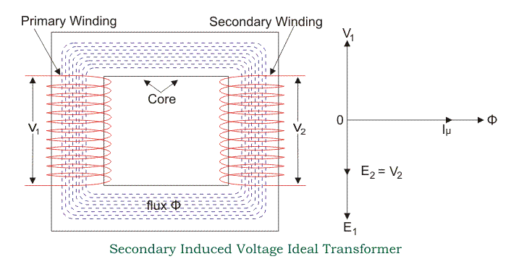
Let's say, T is number of turns in a winding,
Φ_{m} is the maximum flux in the core in Wb. As per Faraday's law of electromagnetic induction,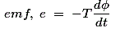
Where φ is the instantaneous alternating flux and represented as,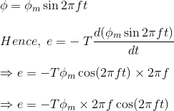

As the maximum value of cos2πft is 1, the maximum value of induced emf e is,To obtain the rms value of induced counter emf, divide this maximum value of e by √2
.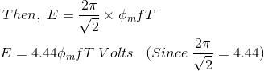
This is EMF equation of transformer.
If E₁ & E₂ are primary and secondary emfs and T₁ & T₂ are primary and secondary turns then, voltage ratio or turns ratio of transformer is
,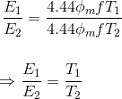

Transformation Ratio of Transformer
This constant is called transformation ratio of transformer , if T₂>T₁, K > 1, then the transformer is step up transformer. If T₂ < T₁, K < 1, then the transformer is step down transformer.

Voltage Ratio of Transformer
This above stated ratio is also known as voltage ratio of transformer if it is expressed as ratio of the primary and secondary voltages of transformer.

Turns Ratio of Transformer
As the voltage in primary and secondary of transformer is directly proportional to the number of turns in the respective winding, the transformation ratio of transformer is sometime expressed in ratio of turns and referred as turns ratio of transformer

2.4 Theory of Transformer on No-Load

Theory of Transformer On No-load, and Having No Winding Resistance and No Leakage Reactance of Transformer
Let us consider one electrical transformer with only core losses, which means, it has only core losses but no copper loss and no leakage reactance of transformer. When an alternating source is applied in the primary, the source will supply the current for magnetizing the core of transformer.
But this current is not the actual magnetizing current; it is little bit greater than actual magnetizing current. Actually, total current supplied from the source has two components, one is magnetizing current which is merely utilized for magnetizing the core and other component of the source current is consumed for compensating the core losses in transformer. Because of this core loss component, the source current in transformer on no-load condition supplied from the source as source current is not exactly at 90° lags of supply voltage, but it lags behind an angle θ is less than 90º.
If total current supplied from source is I_{o}, it will have one component in phase with supply voltage V₁ and this component of the current I_{w} is core loss component. This component is taken in phase with source voltage, because it is associated with active or working losses in transformer. Other component of the source current is denoted as I_{μ}.
This component produces the alternating magnetic flux in the core, so it is watt-less; means it is reactive part of the transformer source current.
Hence I_{μ} will be in quadrature with V₁ and in phase with alternating flux Φ.
Hence, total primary current in transformer on no-load condition can be represented as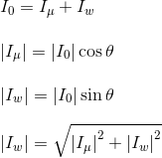Now you have seen how simple is to explain the theory of transformer in-no-load.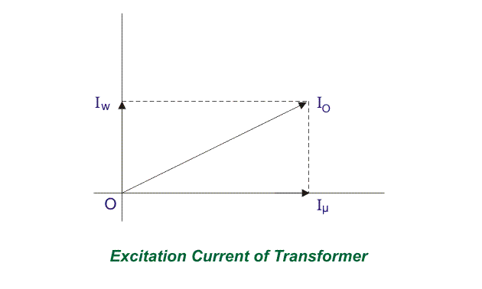

Fig 2.41: Transformer on no load

2.41 Theory of Transformer on Load

Theory of Transformer on Load But Having No Winding Resistance and Leakage Reactance
Now we will examine the behavior of above said transformer on load, that means load is connected to the secondary terminals. Consider, transformer having core loss but no copper loss and leakage reactance. Whenever load is connected to the secondary winding, load current will start to flow through the load as well as secondary winding. This load current solely depends upon the characteristics of the load and also upon secondary voltage of the transformer. This current is called secondary current or load current; here it is denoted as I₂. As I₂ is flowing through the secondary, a self mmf in secondary winding will be produced. Here it is N₂I₂, where, N₂ is the number of turns of the secondary winding of transformer.
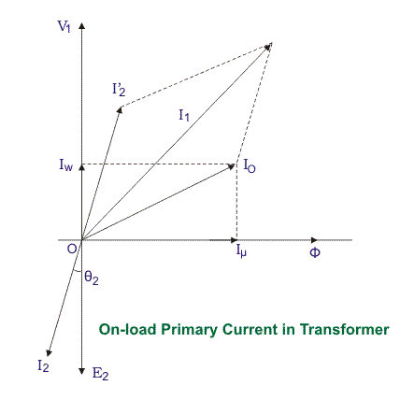
Fig 2.42: phasor diagram
This mmf or magneto motive force in the secondary winding produces flux φ₂. This φ₂ will oppose the main magnetizing flux and momentarily weakens the main flux and tries to reduce primary self induced emf E₁. If E₁ falls down below the primary source voltage V₁, there will be an extra current flowing from source to primary winding. This extra primary current I₂′ produces extra flux φ′ in the core which will neutralize the secondary counter flux φ₂. Hence the main magnetizing flux of core, Φ remains unchanged irrespective of load.
So total current, this transformer draws from source can be divided into two components, first one is utilized for magnetizing the core and compensating the core loss i.e. I_{o}. It is no-load component of the primary current. Second one is utilized for compensating the counter flux of the secondary winding. It is known as load component of the primary current.
Hence total no load primary current I₁ of a electrical power transformer having no winding resistance and leakage reactance can be represented as follows
Where, θ₂ is the angle between Secondary Voltage and Secondary Current of transformer.
Now we will proceed one further step toward more practical aspect of a transformer

Theory of Transformer On Load, With Resistive Winding, But No Leakage Reactance
Now, consider the winding resistance of transformer but no leakage reactance. So far we have discussed about the transformer which has ideal windings, means winding with no resistance and leakage reactance, but now we will consider one transformer which has internal resistance in the winding but no leakage reactance. As the windings are resistive, there would be a voltage drop in the windings.
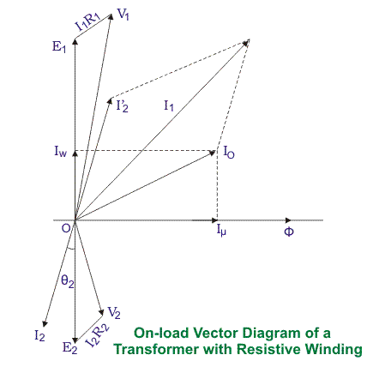
Fig 2.43: phasor diagram

We have proved earlier that, total primary current from the source on load is I₁. The voltage drop in the primary winding with resistance, R₁ is R₁I₁. Obviously, induced emf across primary winding E₁, is not exactly equal to source voltage V₁. E₁ is less than V₁ by voltage drop I₁R₁.
Again in the case of secondary, the voltage induced across the secondary winding, E₂ does not totally appear across the load since it also drops by an amount I₂R₂, where R₂ is the secondary winding resistance and I₂ is secondary current or load current. Similarly, voltage equation of the secondary side of the transformer will be

Theory of Transformer On Load, With Resistance As Well As Leakage Reactance in Transformer Windings
Now we will consider the condition, when there is leakage reactance of transformer as well as winding resistance of transformer.
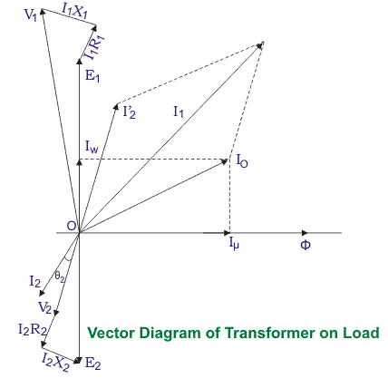
Fig 2.44: phasor diagram
Let leakage reactances of primary and secondary windings of the transformer are X₁ and X₂respectively. Hence total impedance of primary and secondary winding of transformer with resistance R₁ and R₂ respectively, can be represented as,
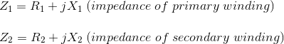
We have already established the voltage equation of a transformer on load, with only resistances in the windings, where voltage drops in the windings occur only due to resistive voltage drop. But when we consider leakage reactances of transformer windings, voltage drop occurs in the winding not only because of resistance, it is because of impedance of transformer windings. Hence, actual voltage equation of a transformer can easily be determined by just replacing resistances R₁ & R₂ in the previously established voltage equations by Z₁ and Z₂.
Therefore, the voltage equations are,
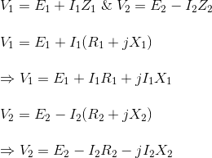
Resistance drops are in the direction of current vector but, reactive drop will be perpendicular to the current vector as shown in the above vector diagram of transformer.

Resistance and Leakage Reactance or Impedance of Transformer

Leakage Reactance of Transformer
All the flux in transformer will not be able to link with both the primary and secondary windings. A small portion of flux will link either winding but not both. This portion of flux is called leakage flux. Due to this leakage flux in transformer, there will be a self-reactance in the concerned winding. This self-reactance of transformer is alternatively known as leakage reactance of transformer. This self-reactance associated with resistance of transformer is impedance. Due to this impedance of transformer, there will be voltage drops in both primary and secondary transformer windings.

Resistance of Transformer
Generally, both primary and secondary windings of electrical power transformer are made of copper. Copper is a very good conductor of current but not a super conductor. Actually, super conductor and super conductivity both are conceptual, practically they are not available. So both windings will have some resistance. This internal resistance of both primary and secondary windings is collectively known as resistance of transformer.

Impedance of Transformer
As we said, both primary and secondary windings will have resistance and leakage reactance. These resistance and reactance will be in combination, is nothing but impedance of transformer. If R₁ and R₂ and X₁ and X₂ are primary and secondary resistance and leakage reactance of transformer respectively, then Z₁ and Z₂ impedance of primary and secondary windings are respectively,
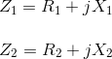
The Impedance of transformer plays a vital role during parallel operation of transformer.

Leakage Flux in Transformer
In ideal transformer, all the flux will link with both primary and secondary windings but in reality, it is impossible to link all the flux in transformer with both primary and secondary windings. Although maximum flux will link with both windings through the core of transformer but still there will be a small amount of flux which will link either winding but not both. This flux is called leakage flux which will pass through the winding insulation and transformer insulating oil instead of passing through core. Due to this leakage flux in transformer, both primary and secondary windings have leakage reactance. The reactance of transformer is nothing but leakage reactance of transformer. This phenomenon in transformer is known as Magnetic leakage.
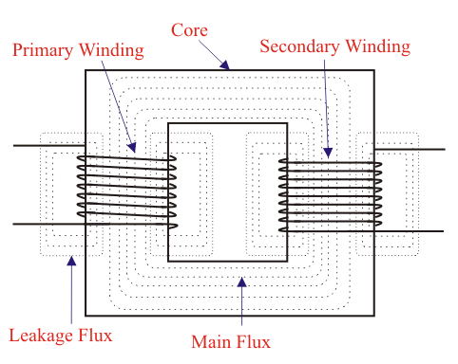
Fig 2.42: Transformer with leakage flux
Voltage drops in the windings occur due to impedance of transformer.
Impedance is combination of resistance and leakage reactance of transformer. If we apply voltage V₁ across primary of transformer, there will be a component I₁X₁ to balance primary self induced emf due to primary leakage reactance. (Here, X₁ is primary leakage reactance). Now if we also consider voltage drop due to primary resistance of transformer, then voltage equation of a transformer can easily be written as,
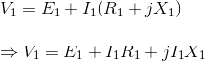
Similarly for secondary leakage reactance, the voltage equation of secondary side is,
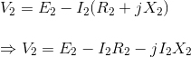
Here in the figure above, the primary and secondary windings are shown in separate limbs and this arrangement could result a large leakage flux in transformer because there is a big room for leakage. Leakage in primary and secondary windings could be eliminated if the windings could be made to occupy the same space. This of course is physically impossible but, by placing secondary and primary in concentric manner can solve the problem in good extent.

2.5 Equivalent Circuit of Transformer
Equivalent impedance of transformer is essential to be calculated because the electrical power transformer is an electrical power system equipment for estimating different parameters of electrical power system which may be required to calculate total internal impedance of an electrical power transformer, viewing from primary side or secondary side as per requirement. This calculation requires equivalent circuit of transformer referred to primary or equivalent circuit of transformer referred to secondary sides respectively. Percentage impedance is also very essential parameter of transformer. Special attention is to be given to this parameter during installing a transformer in an existing electrical power system. Percentage impedance of different power transformers should be properly matched during parallel operation of power transformers. The percentage impedance can be derived from equivalent impedance of transformer so, it can be said that equivalent circuit of transformer is also required during calculation of % impedance.

Equivalent Circuit of Transformer Referred to Primary
For drawing equivalent circuit of transformer referred to primary, first we have to establish general equivalent circuit of transformer then, we will modify it for referring from primary side. For doing this, first we need to recall the complete vector diagram of a transformer which is shown in the figure below.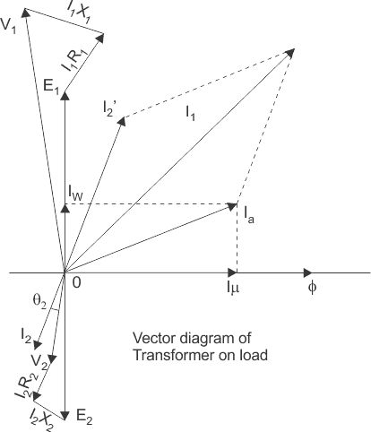
Let us consider the transformation ratio be,
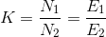
In the figure above, the applied voltage to the primary is V₁ and voltage across the primary winding is E₁. Total current supplied to primary is I₁. So the voltage V₁ applied to the primary is partly dropped by I₁Z₁ or I₁R₁ + j.I₁X₁ before it appears across primary winding. The voltage appeared across winding is countered by primary induced emf E₁. So voltage equation of this portion of the transformer can be written as
,
The equivalent circuit for that equation can be drawn as below,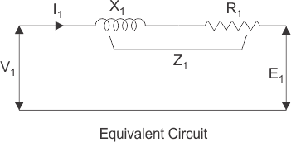
From the vector diagram above, it is found that the total primary current I₁ has two components, one is no - load component I_{o} and the other is load component I₂′. As this primary current has two components or branches, so there must be a parallel path with primary winding of transformer. This parallel path of current is known as excitation branch of equivalent circuit of transformer. The resistive and reactive branches of the excitation circuit can be represented as
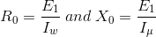
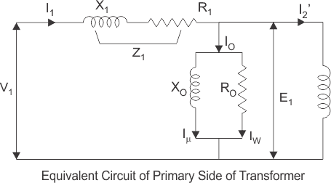
The load component I₂′ flows through the primary winding of transformer and induced voltage across the winding is E₁ as shown in the figure right. This induced voltage E₁transforms to secondary and it is E₂ and load component of primary current I₂′ is transformed to secondary as secondary current I₂. Current of secondary is I₂. So the voltage E₂ across secondary winding is partly dropped by I₂Z₂ or I₂R₂ + j.I₂X₂ before it appears across load. The load voltage is V₂.
The complete equivalent circuit of transformer is shown below.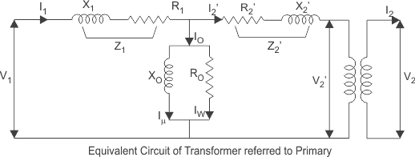

Now if we see the voltage drop in secondary from primary side, then it would be ′K′ times greater and would be written as K.Z₂.I₂.
Again I₂′.N₁ = I₂.N₂
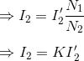
Therefore,
From above equation, secondary impedance of transformer referred to primary is,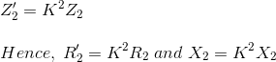
So, the complete equivalent circuit of transformer referred to primary is shown in the figure below,

Approximate Equivalent Circuit of Transformer
Since I_{o} is very small compared to I₁, it is less than 5% of full load primary current, I_{o}changes the voltage drop insignificantly. Hence, it is good approximation to ignore the excitation circuit in approximate equivalent circuit of transformer. The winding resistance and reactance being in series can now be combined into equivalent resistance and reactance of transformer, referred to any particular side. In this case it is side 1 or primary side.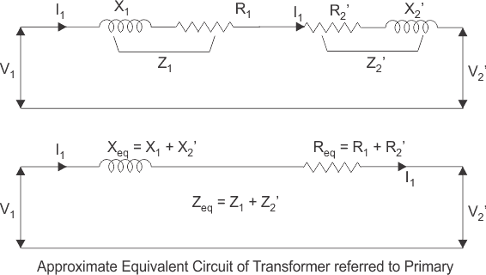

Equivalent Circuit of Transformer Referred to Secondary
In similar way, approximate equivalent circuit of transformer referred to secondary can be drawn.
Where equivalent impedance of transformer referred to secondary, can be derived as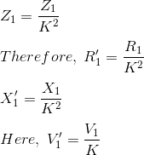

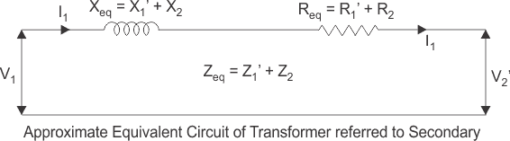

2.6 Voltage Regulation of Transformer
The voltage regulation is the percentage of voltage difference between no load and full load voltages of a transformer with respect to its full load voltage.

Explanation of Voltage Regulation of Transformer
Say an electrical power transformer is open circuited, means load is not connected with secondary terminals. In this situation, the secondary terminal voltage of the transformer will be its secondary induced emf E₂. Whenever full load is connected to the secondary terminals of the transformer, rated current I₂ flows through the secondary circuit and voltage drop comes into picture. At this situation, primary winding will also draw equivalent full load current from source. The voltage drop in the secondary is I₂Z₂ where Z₂ is the secondary impedance of transformer.
Now if at this loading condition, any one measures the voltage between secondary terminals, he or she will get voltage V₂ across load terminals which is obviously less than no load secondary voltage E₂ and this is because of I₂Z₂ voltage drop in the transformer.

Expression of Voltage Regulation of Transformer
Expression of Voltage Regulation of Transformer, represented in percentage, is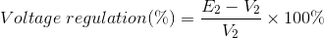

Voltage Regulation of Transformer for Lagging Power Factor
Now we will derive the expression of voltage regulation in detail. Say lagging power factor of the load is cosθ₂, that means angle between secondary current and voltage is θ₂.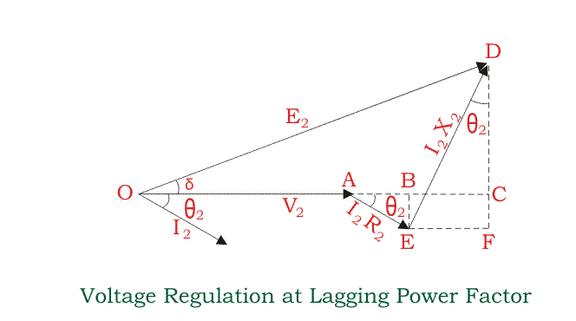Here, from the above diagram,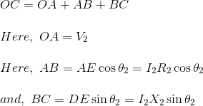Angle between OC and OD may be very small, so it can be neglected and OD is considered nearly equal to OC i.e.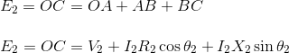
Voltage regulation of transformer at lagging power factor,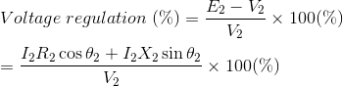

Voltage Regulation of Transformer for Leading Power Factor
Let's derive the expression of voltage regulation with leading current, say leading power factor of the load is cosθ₂, that means angle between secondary current and voltage is θ₂.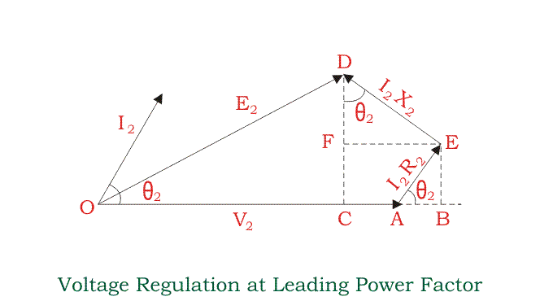Here, from the above diagram,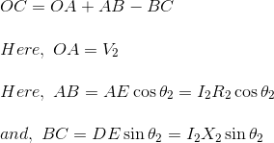Angle between OC and OD may be very small, so it can be neglected and OD is considered nearly equal to OC i.e.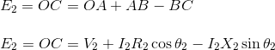
Voltage regulation of transformer at leading power factor,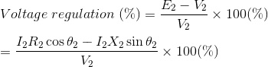

2.6 TRANSFORMER TESTS
All the transformers are tested before placing them in the field. By performing these tests, we can determine the parameters of a transformer to compute its performance characteristics (like voltage regulation and efficiency.).
To furnish the required information, open circuit and short circuit tests are conducted conveniently without actually loading the transformer.
Open-circuit or No-load Test
This test is carried out to determine the no-load loss or core loss or iron loss and no-load current I₀which is helpful in finding the no-load parameters, that is, exciting resistance R₀ and X₀ exciting reactance of the transformer.
This test is usually carried out on the low-voltage side of the transformer, that is, a watt meter W, a voltmeter V, and an ammeter A are connected in low-voltage winding (say primary). The primary winding is then connected to the normal rated voltage V₁ and frequency as given on the name plate of the transformer. The secondary side is kept open or connected to a voltmeter V′ as shown in Figure 10.31(a). Since the secondary (high-voltage winding) is open circuited, the current drawn by the primary is called no-load current I₀ measured by the ammeter A. The value of no-load current I₀ is very small usually 2 to 10% of the rated full-load current. Thus, the copper loss in the primary is negligibly small and no copper loss occurs in the secondary as it is open. Therefore, wattmeter reading W₀ only represents the core or iron losses for all practical purposes. These core losses are constant at all loads. The voltmeter V′ if connected on the secondary side measures the secondary induced voltage V₂.
(0-500mA)
MI
(150V,1A,LPF)
P
N
1∅,230V,50Hz AC Supply
1A
1A
A
-
V
M
L
C
V
(0-150V)
MI
115V
230V
1KVA
230V/(0-270V)
4.05 KVA
O.C TEST

Fig. (a) Circuit for open circuit test
Open circuit test
I_{O} = open circuit current , mA
V_{O} = open circuit voltage, Volts
W_{O} = open circuit power, Watts
W_{O} = V_{O} * I_{O} * cos∅_{O ,} Watts
where , cos∅_{O} = No load power factor.
∴ cos∅_{O} = W_{O}/(V_{O} * I_{O})
I_{w} = working current = I_{O} * cos ∅_{O}
I_{m} = magnetizing current = I_{O} * sin ∅_{O}
R_{m} = V_{O}/I_{w}
X_{m} = V_{O}/I_{m}
The Iron losses measured by this test are used to determine transformer efficiency and parameters of exciting circuit of a transformer shown in Figure 10.32.

Short Circuit Test
This test is carried out to determine the following:
- Copper losses at full load (or at any desired load). These losses are required for the calculations of efficiency of the transformer.
- Equivalent impedance (Z_{es} or Z_{ep}), resistance (R_{es} or R_{ep}) and leakage reactance (X_{es} or X_{ep}) of the transformer referred to the winding in which the measuring instruments are connected. Knowing equivalent resistance and reactance, the voltage drop in the transformer can be calculated and hence regulation of transformer is determined.
This test is usually carried out on the high-voltage side of the transformer, that is, a wattmeter W, voltmeter V, and an ammeter A are connected in high-voltage* winding (say secondary). The other winding (primary) is then short circuited by a thick strip or by connecting an ammeter A′ across the terminals as shown in Figure 10.33. A low voltage at normal frequency is applied to the high-voltage winding with the help of on autotransformer so that full-load current flows in both the windings, measured by ammeters A and A′. Low voltage is essential, failing which an excessive current will flow in both the windings that may damage them. Since a low voltage (usually 5 to 10% of normal rated voltage) is applied to the transformer winding, therefore, the flux set-up in the core is very small .
The iron losses are negligibly small due to low value of flux as these losses are approximately proportional to the square of the flux. Hence, wattmeter reading W_{c} only represents the copper losses in the transformer windings for all practical purposes. The applied voltage V_{2sc} is measured by the voltmeter V which circulates the current I_{2sc} (usually full-load current) in the impedance Z_{es} of the transformer to the side in which instruments are connected as shown in Figure 10.33.
Let the wattmeter reading = W_{c}
P
N
1∅,230V,50Hz AC Supply
supply
5A
5A
A
-
V
M
L
C
V
(0-5A), MI
(0-75V)
MI
(75V,5A,UPF)
230V
115V
1KVA
230V/(0-270V)
4.05KVA
S.C. TEST

Fig. 10.33 Circuit for short circuit test

Short circuit test

I_{SC} = short circuit current, Amps
V_{SC} = voltage applied in the short circuit test, Volts
W_{SC} = power consumed in short circuit test, Watts
W_{SC} = V_{SC} * I_{SC} * cos∅_{SC ,} Watts
∴ cos∅_{SC} = W_{SC}/(V_{SC} * I_{SC})
Z_{O2} = V_{SC} /I_{SC}
R_{O2} = Z_{O2} * cos∅_{SC}
X_{O2} = Z_{O2} * sin∅_{SC}
R_{O1} = R_{O2}/K² ; X_{O1} = X_{O2}/K²
where,K = tranformation ratio= V₂/V₁
After calculating R_{es} and X_{es}, the voltage regulation of the transformer can be determined at any load and power factor.

3.10 Efficiency
Equipment is desired to operate at a high efficiency. Fortunately, losses in transformers are small. Because the transformer is a static device, there are no rotational losses such as windage and friction losses in a rotating machine. In a well-designed transformer the efficiency can be as high as 99%. The efficiency is defined as follows:
$η=\frac{\text{output} \text{power} \left(P_{\text{out}}\right)}{\text{Input} \text{Power}\left(P_{\text{in}}\right)}∗\text{100}=\frac{P_{\text{out}}}{P_{\text{out}}+\text{Losses}}∗\text{100}$ (3.14)
The losses in the transformer are the core loss $\left(P_{c}\right)$ and copper loss $\left(P_{\text{cu}}\right)$. Therefore,
$η=\frac{P_{\text{out}}}{P_{\text{out}}+\text{Losses}}=\frac{P_{\text{out}}}{P_{\text{out}}+P_{c}+P_{\text{cu}}}$ (3.15)
The copper loss can be determined if the winding currents and their resistances are known:
$\begin{aligned}P_{\text{cu}}=I_{1}^{2}R_{1}+I_{2}^{2}R_{2} \\ = I_{1}^{2}R_{\text{eq}1}=I_{2}^{2}R_{\text{eq}2}\end{aligned}$ (3.16)
The copper loss is a function of the load current.
The core loss depends on the peak flux density in the core, which in turn depends on the voltage applied to the transformer. Since a transformer remains connected to an essentially constant voltage, the core loss is almost constant and can be obtained from the no-load test of a transformer. Therefore, if the parameters of the equivalent circuit of a transformer are known, the efficiency of the transformer under any operating condition may be determined. Now,
$$P_{\text{out}}=V_{2}I_{2}\text{cos}ϕ_{2}$$
Therefore,
$η=\frac{V_{2}I_{2}\text{cos}ϕ_{2}}{V_{2}I_{2}\text{cos}ϕ_{2}+P_{c}+I_{2}^{2} R_{\text{eq}2}}$* 100 (3.17)
$η=\frac{V_{2}^{'}∗I_{2}^{'} \text{*cos} ϕ_{2}}{V_{2}^{'}∗I_{2}^{'} \text{*cos} ϕ_{2}+P_{c}+I_{2}^{}R_{\text{eq}1}}∗\text{100}$ (3.18)

3.11 Maximum Efficiency
For constant values of the terminal voltage $V_{2}$and load power factor angle $ϕ_{2}$, the maximum efficiency occurs when:
$\frac{dη}{{\text{dI}}_{2}}=0$ (3.19)
If this condition is applied to Eqn. (3.17) the condition for maximum efficiency is:
$P_{c}=I_{2}^{2}R_{\text{eq}2}$ (3.20)
That is, core loss = copper loss. For full load condition,
$P_{\text{cu},\text{FL}}=I_{2,\text{FL}}^{2}R_{\text{eq}2}$ (3.21)
Let $x=\frac{I_{2}}{I_{2,\text{FL}}}=\text{per} \text{unit} \text{loading}$ (3.22)
From Eqns. (3.20), (3.21) and (3.22).
$P_{c}=x^{2}P_{\text{cu},\text{FL}}$ (3.23)
Then, $x=\sqrt{\left(\frac{P_{c}}{P_{\text{cu},\text{FL}}}\right)}$ (3.24)
For constant values of the terminal voltage $V_{2}$and load current $I_{2}$, the maximum efficiency occurs when:
$\frac{dη}{{dϕ}_{2}}=0$ (3.25)
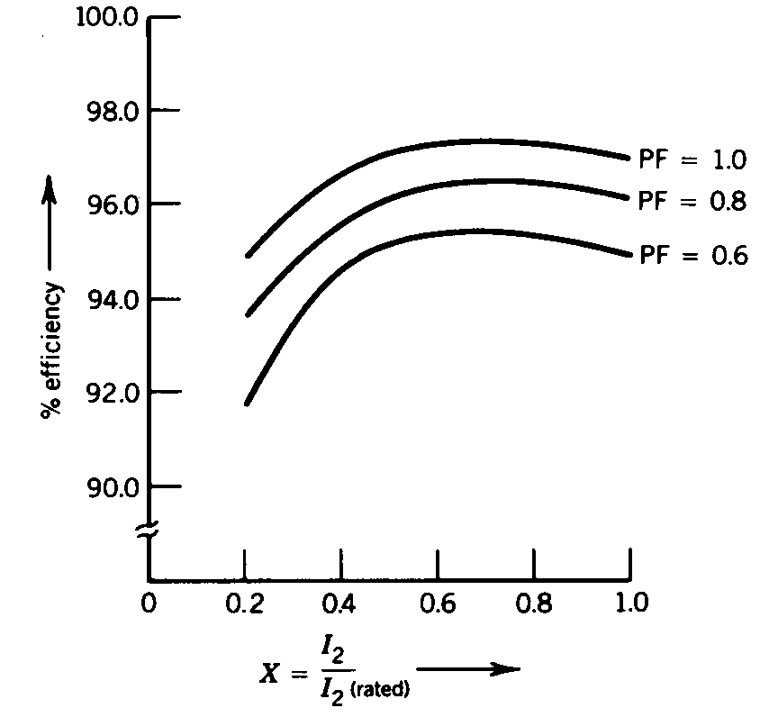
Fig.3.17 Efficiency of a transformer.

If this condition is applied to Eq.(3.17), the condition for maximum efficiency is
$$ϕ_{2}=0 \text{Then}, \text{cos}ϕ_{2}=1$$
that is, load power factor = 1
Therefore, maximum efficiency in a transformer occurs when the load power factor is unity (i.e., resistive load) and load current is such that copper loss equals core loss. The variation of efficiency with load current and load power factor is shown in Fig.3.17.

